中嘉新聞(香港發明展)
https://www.facebook.com/newscns/videos/392240588195296/
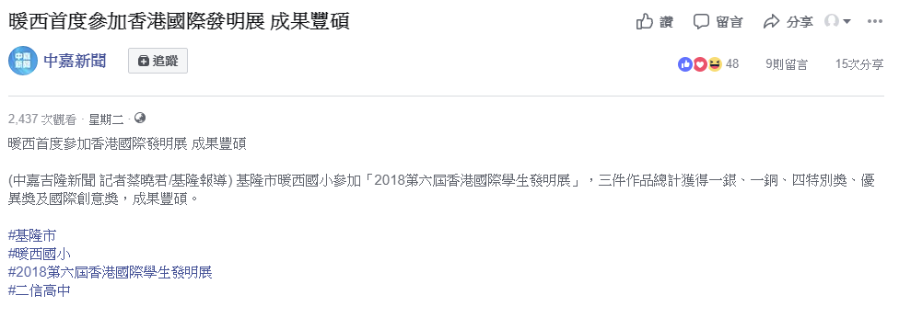
台灣新生報yahoo
https://tw.news.yahoo.com/%E6%8F%9A%E5%A8%81%E9%A6%99%E6%B8%AF%E7%99%BC%E6%98%8E%E5%B1%95-%E6%9A%96%E8%A5%BF%E5%9C%8B%E5%B0%8F%E7%8D%8E%E4%B8%8D%E5%AE%8C-160000183.html
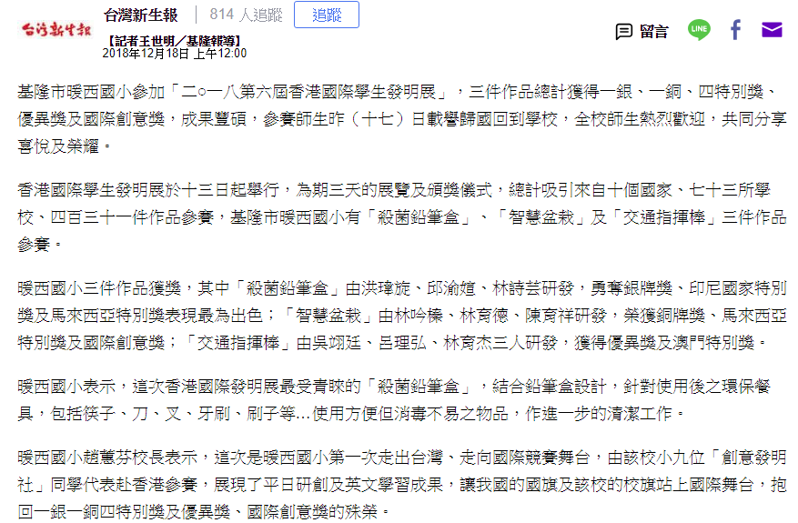
聯合電子報
https://udn.com/news/story/7328/3541321
